Hot Off the Press!
Announcing the release of Becoming a Sustainable Organization written by Kristina Kohl MBA, PMP

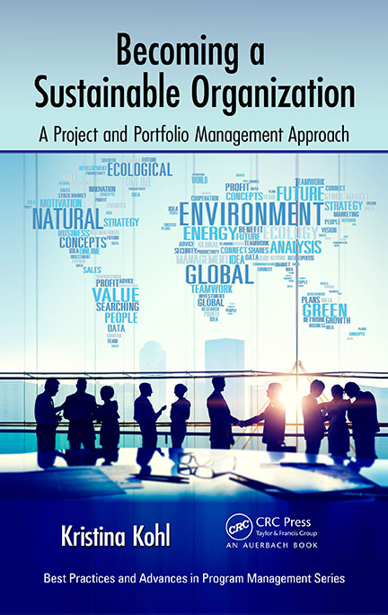

Summary
Organizations find that a performance gap exists between sustainability vision and benefits realization. Effecting transformational change requires incorporating sustainability into an organization’s culture including policies, processes, and people. This book lays out a framework to improve sustainability integrations including case studies, lessons learned, best practices, and tools and templates to facilitate transforming into a sustainable organization. The following is the companion website: www.becomingsustainable.org
Becoming a Sustainable Organization: A Project and Portfolio Management Approach is an ideal resource for project and portfolio managers, as well as executive managers, in organizations that are embarking on a sustainability journey. It explains how to engage both internal and external stakeholders in order to reframe strategy to drive this transformation. It examines the role human capital management professionals and policies can play in ensuring that employees become fully engaged in sustainability. It also recommends baseline measurements and metrics to help managers ensure sustainability initiatives remain on track.
The case studies and interviews in this book include sustainability stories and projects from a variety of organizations in both function and size, including family-owned businesses, higher-education institutions, NGOs, municipal and federal government agencies, and large global organizations. These cases are based on interviews with experienced sustainability and project management professionals who have not just "talked the talk" but also "walked the walk."
The voices of these professionals provide invaluable inspiration and guidance to sustainability champions and to program and project managers tasked with moving their sustainability portfolio components forward within their organizations.
About the Author:

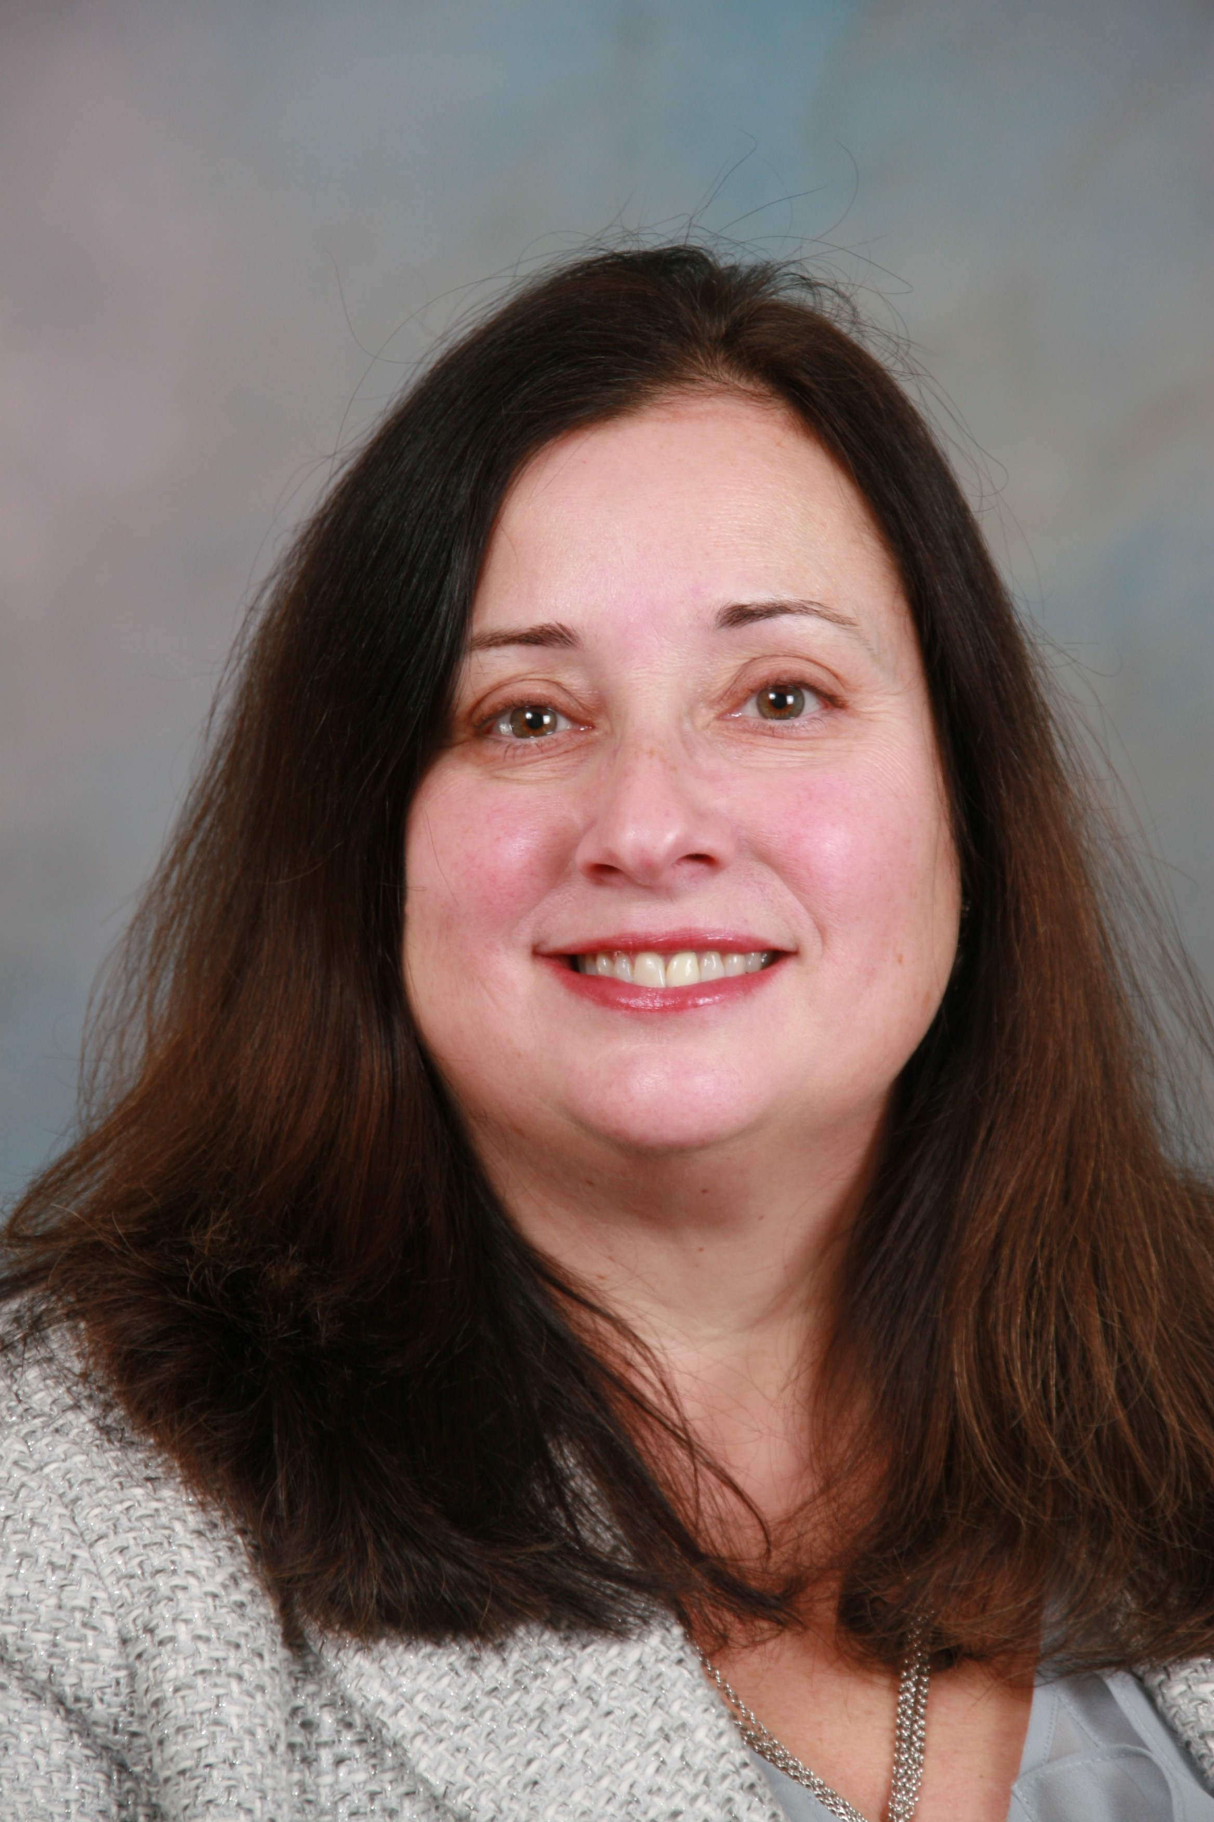
Kristina is the managing principal of Becoming Sustainable a division of HRComputes, which provides strategic guidance to senior management to maximize the value proposition of sustainable strategy. Kris has spoken at global conferences including the PMI Global Congress and the Society for Human Resource Management Annual Conference and has been a guest lecturer at numerous institutions and events. In addition, she has contributed white papers and articles to various organizations and publications. Kristina holds an MBA from the Wharton School, University of Pennsylvania. She is also a Project Management Institute member and a certified PMP.
Please contact her at Kris@HRComputes.com or follow her @KrisKohl

Available Through Amazon and CRC Press:
CRCpress.com/Becoming-a-Sustainable-Organization-A-Project-and-Portfolio-Management/Kohl/9781498700818
http://www.amazon.com/Becoming-Sustainable-Organization-Portfolio-Management-ebook/dp/B01DVTEU9I/ref=mt_kindle?_encoding=UTF8&me=

